Italo Cufiño Novoa

//Mateo Guzman

Git add .

* Guarda los nuevos cambios de toda la carpeta

git commit -m "Message"

* darle un comentario a la versión nueva

git remote add origin <server>

* poder crear un repositorio remote

git push origin master

* envía los cambio locales al repositorio público

git clone <repository>

* crea un repositorio en un directorio recién creado

git pull origin master

* extraerá los cambios desde el remoto de origen , la rama maestra y los fusionará con la rama local des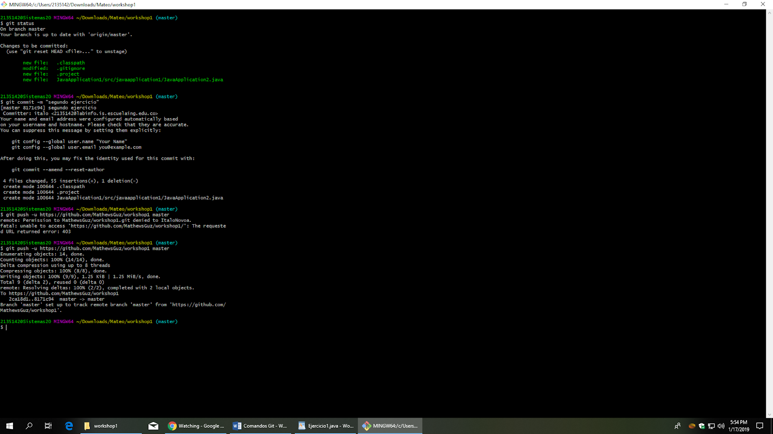protegida.

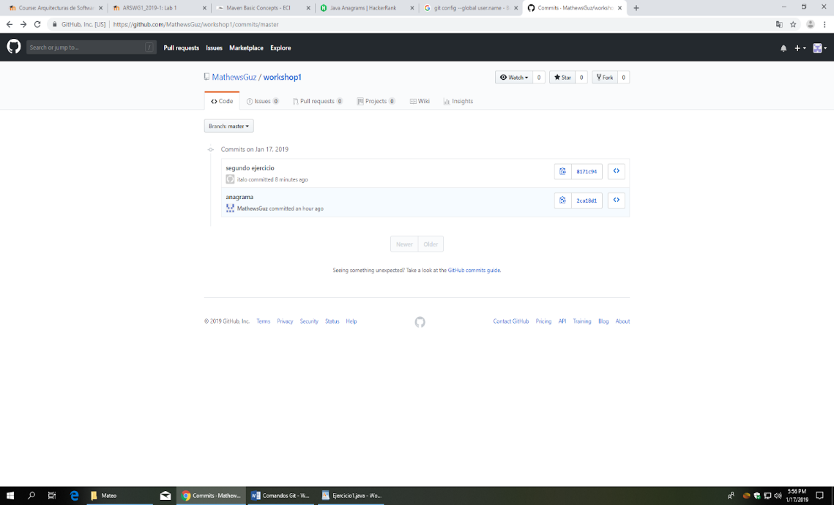

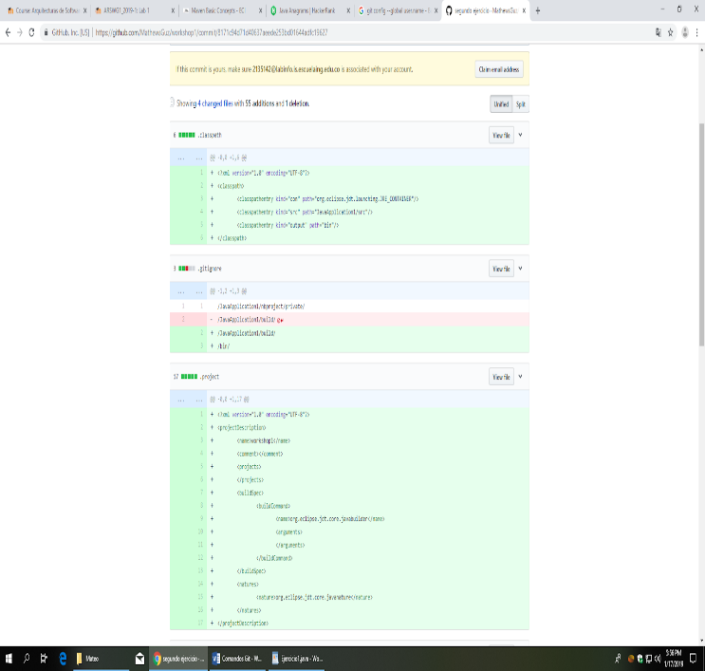

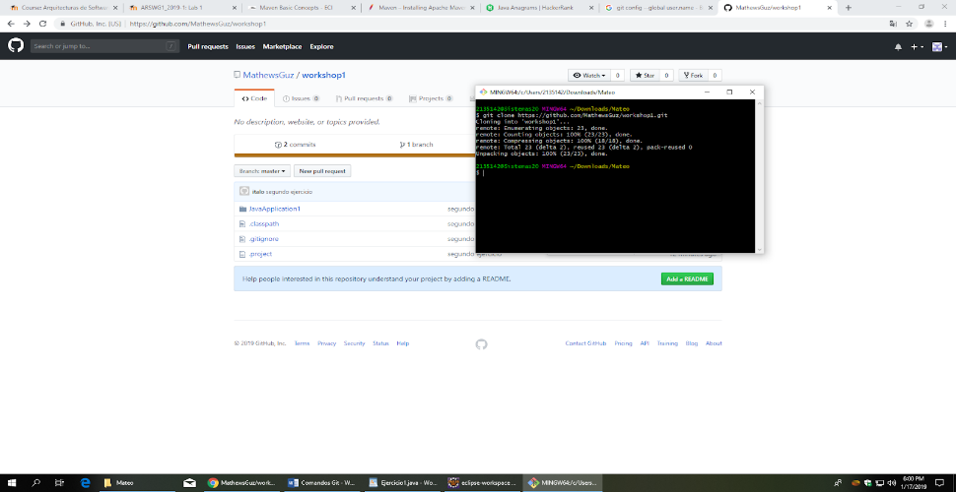

**MAVEN**

Descarga de repositorio maven

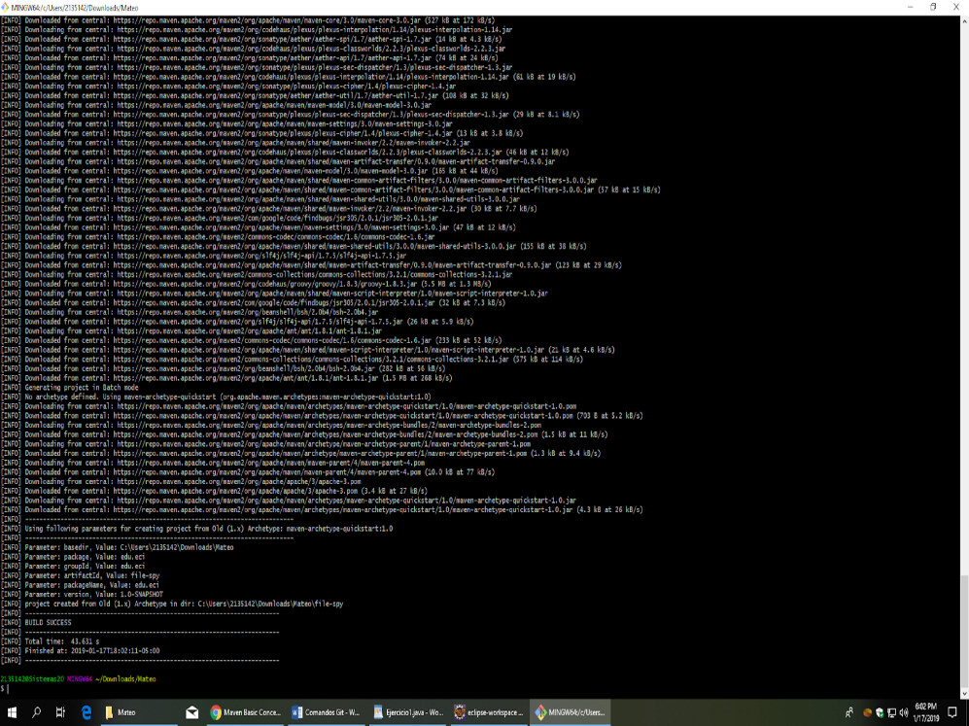

**What do means the -B option in the command?**

-B,--batch-mode    Run in non-interactive (batch) mode (disables output color)

**What do means the -D option in the command?**

-D,--define <arg>  definir un sistema propio Además dar valor a la propiedad scm.password al ejecutar mvn

**What do means the groupId, artifactId properties in the command?**

* **groupId** uniquely identifies your project across all projects.
* **artifactId** is the name of the jar without version. If you created it, then you can choose whatever name you want with lowercase letters and no strange symbols.
* **Create the folders src/main/resources` and `src/test/resources**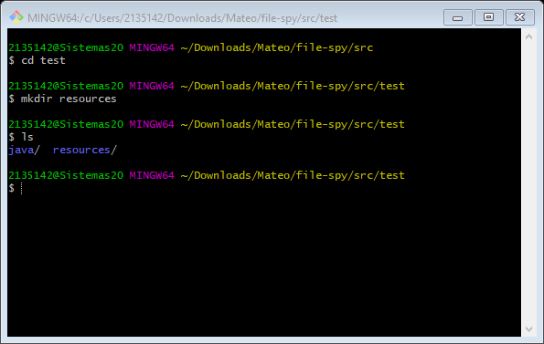

**What do means the word SNAPSHOT in the version value?**

<version>1.0-SNAPSHOT</version>

Es un tipo de versión la cual hace referencia a un trabajo en progreso

**What is the purpose of the packing tag into the POM file?**

Es tener la información presente en cuanto a sus librerías como aplicaciones.

**What is the purpose of the dependencies and dependency tags into the POM file?**

Son utilizadas para que el Proyecto pueda hacer uso de estas sin tener la necesidad de descargar más librerías en un jar.

**What is the functionality of this class?**

* **The three principal Maven lifecycles are clean, defaultand site. Describe each one.**

<https://maven.apache.org/guides/introduction/introduction-to-the-lifecycle.html>

<https://maven.apache.org/plugins/maven-clean-plugin/plugin-info.html>

There are three built-in build lifecycles: default, clean and site. The default lifecycle handles your project deployment, the clean life cycle handles project cleaning, while the site lifecycle handles the creation of your project's site documentation.

* **Using the terminal execute the command mvn compile. Take the output screenshot. What is this command using for? What are transitive dependencies?**
* **Using the terminal execute the command mvn package. Take the output screenshot. What is this command using for?**
* **Using the terminal execute the command mvn install. Take the output screenshot. What is this command using for?**
* **Generate a new maven project in other folder using the maven command line tools, this project should has as groupId "edu.eci" and as artifactId "another-maven-project". Take the output screenshot.**
* **Replace the code of the App.java class with the following code and do all the necessary steps to compile the code.**

A Build Lifecycle is Made Up of Phases

Each of these build lifecycles is defined by a different list of build phases, where in a build phase represents a stage in the lifecycle.

For example, the default lifecycle comprises of the following phases (for a complete list of the lifecycle phases, refer to the Lifecycle Reference):

   validate - validate the project is correct and all necessary information is available

   compile - compile the source code of the project

   test - test the compiled source code using a suitable unit testing framework. These tests should not require the code be packaged or deployed

   package - take the compiled code and package it in its distributable format, such as a JAR.

   verify - run any checks on results of integration tests to ensure quality criteria are met

   install - install the package into the local repository, for use as a dependency in other projects locally

   deploy - done in the build environment, copies the final package to the remote repository for sharing with other developers and projects.

compila el proyecto y deja el resultado en target/classes

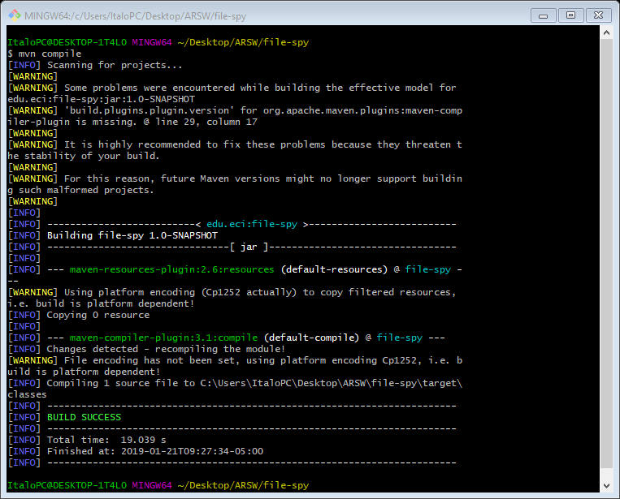

Dependencia transitiva

Se genera cuando la dependia se genera a traves de un intermedia que las une a ambas logicamente

Mvn package

empaqueta el proyecto y lo dejará en taget/autentiaNegocio-1.0-SNAPSHOT.jar

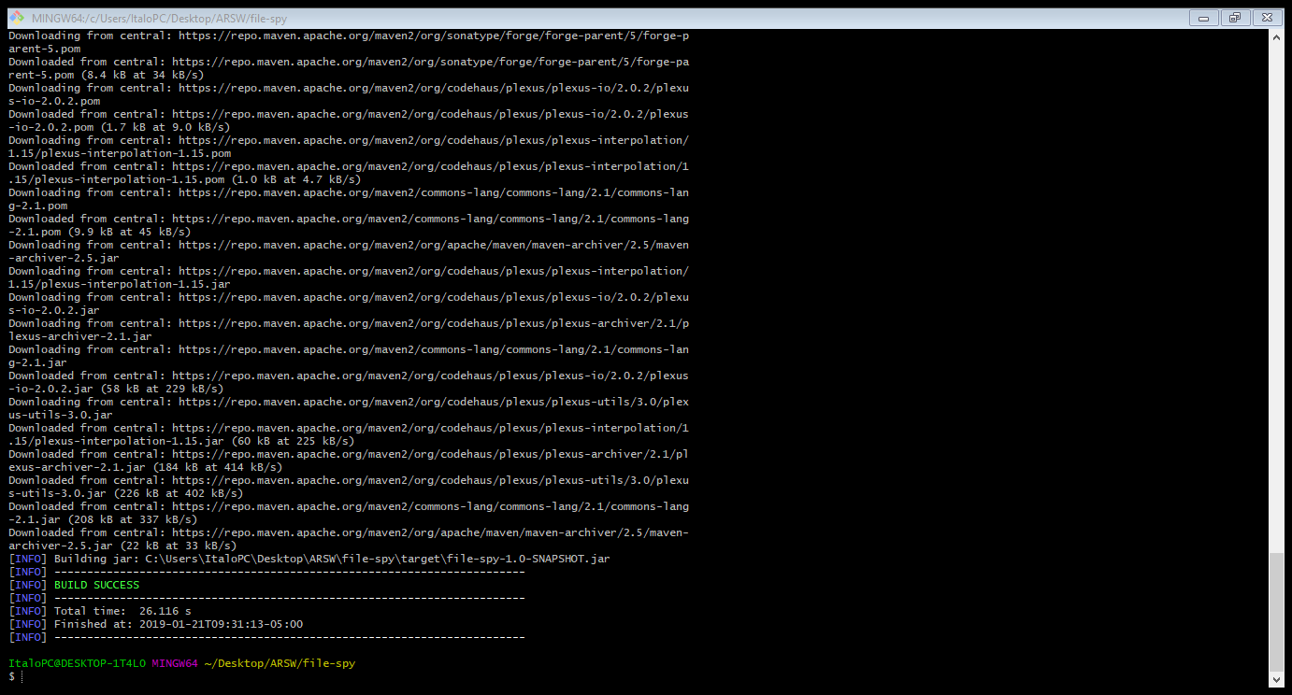

**Mvn install**

guarda el proyecto en el repositorio

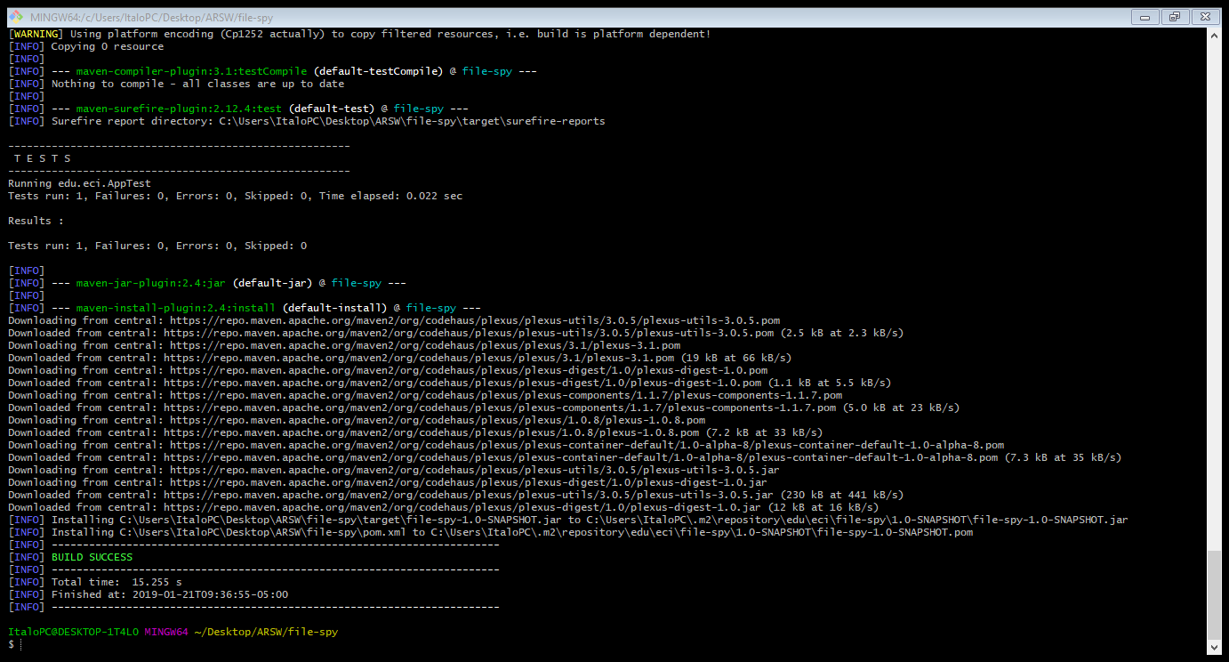

**another-maven-project**

